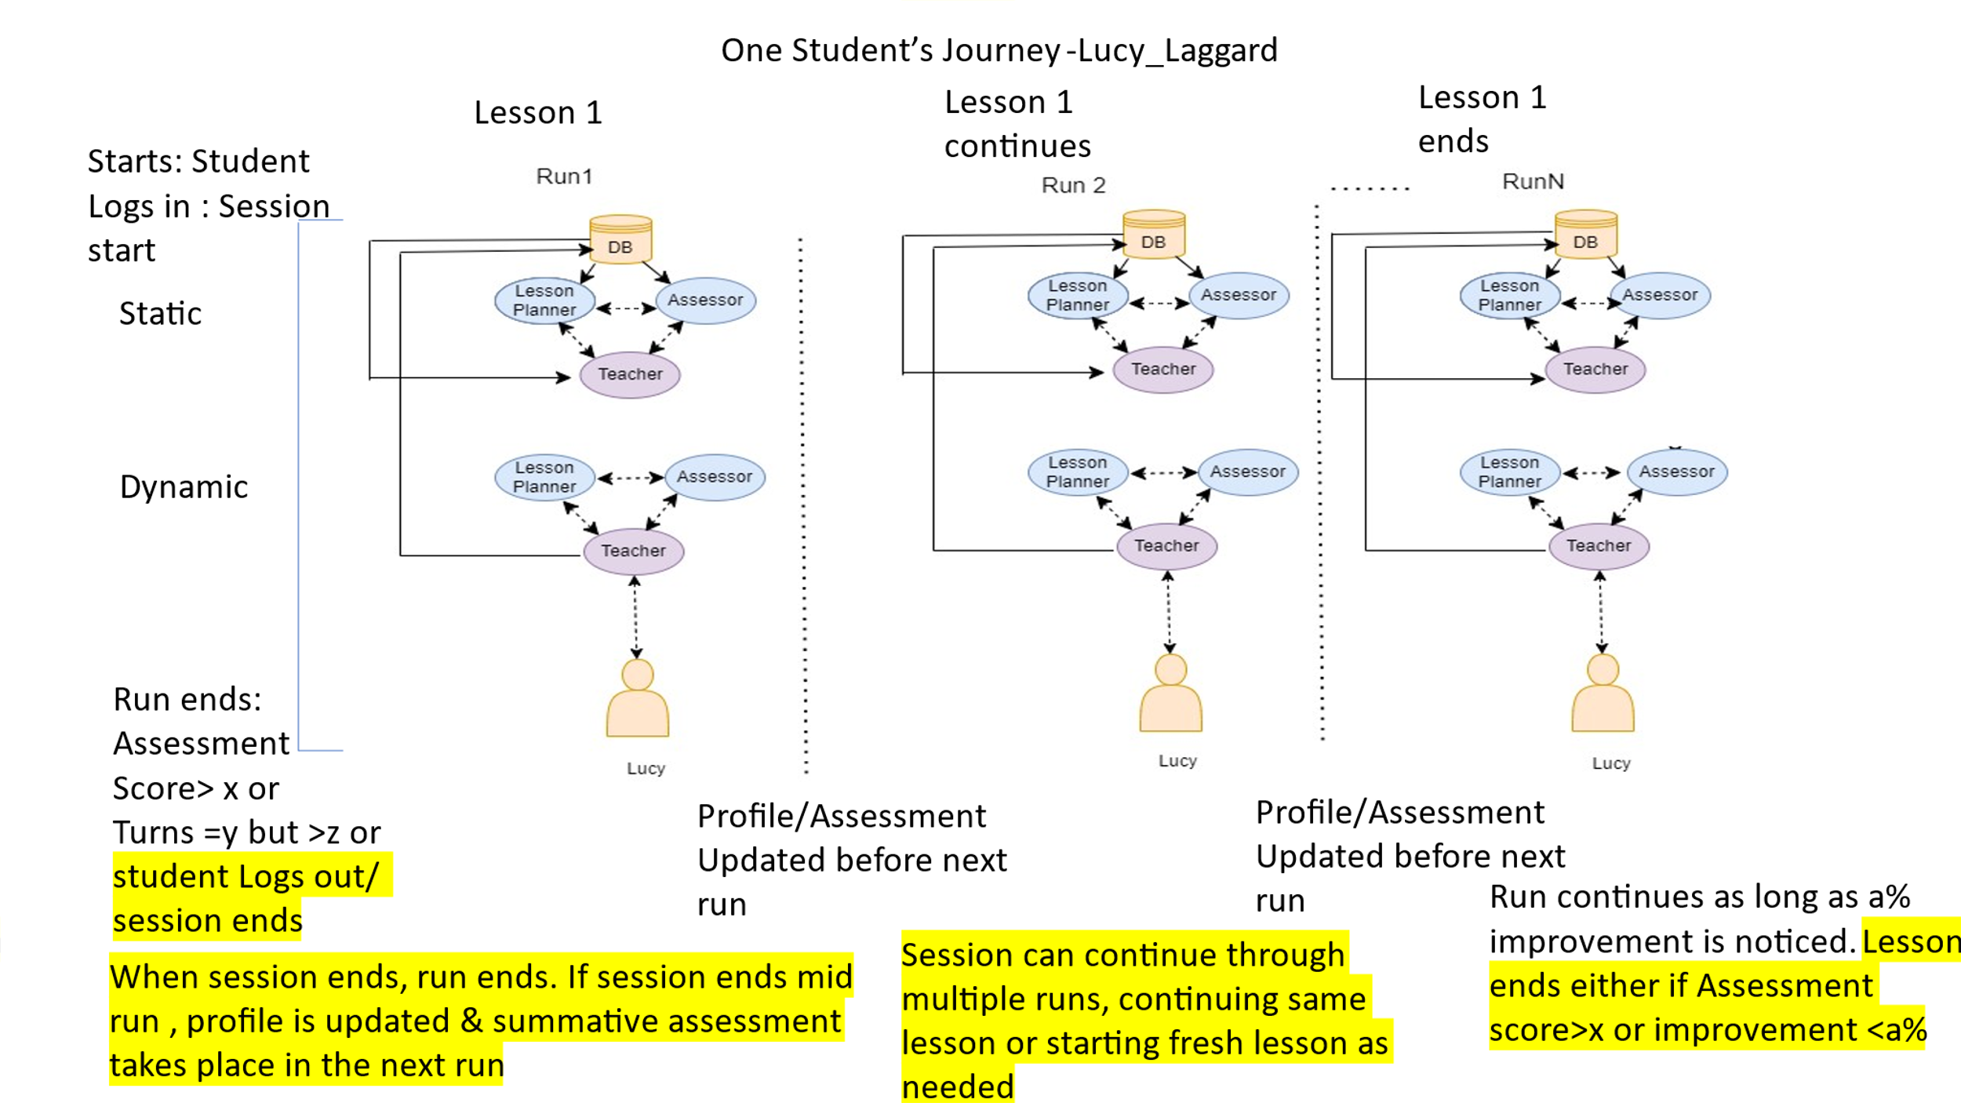

The Ultimate Human Student MA system interaction has to follow the following pattern:

1. Student Logs in and Session starts
2. Student chooses role or has corresponding profile preassessment file fetched from stored database
3. Static Part starts where Lesson Planner chooses initial lesson Plan Assessor chooses initial assessment plan
4. Teacher receives initial Profile, Preassessment file, Lesson Plan, Assessment Plan and prepares to teach
5. Dynamic part starts with teacher student interaction
6. If Teacher finds that student has difficulties to understand certain topics, he asks about student interests, learning preference
7. New lesson Plan and Assessment Plan created with the obtained information
8. Teacher teaches according to new plan, keeps assessing as he teaches till the topics are covered or turns (one turn=count of enter pressed by Human student) are exhausted. There is a minimum number of turns that must be completed before lesson stops
9. Teacher now questions the student on all topics taught
10. Assessment Score over all topics is updated to the Pre- Assessment file, Profile is updated with interests.
11. Session ends with student log out but if student logs out mid run, run also ends there and profile is updated but assessment is done in the next run
12. If student does not logout and score>x, then next run begins with new lesson and session continues
13. If student does not logout and score<x, then next run begins with portions of first lesson not covered/answered correctly in first lesson
14. If student logs out and score<x then in the next session, a new run begins with portions of first lesson not covered/answered correctly in first lesson
15. Runs continue as long as score<x & improvement in Assessment score over last run > a
16. Lesson completes if either score > x or improvement in Assessment score over last run < a

**Currently the program is assuming that the student has logged in with a specific role i.e. Shepherd_medium and we are merely checking that the static and dynamic portions work as expected. No other part, assessment score etc. is being properly computed at this time**

**The interaction between all agents (teacher, Lesson planner and assessor) is happening in the backend and is not displayed in the streamlit environment**

**We are using streamlit run “program name” to run the program**